2. **Topic name:** *Lab7_topic*

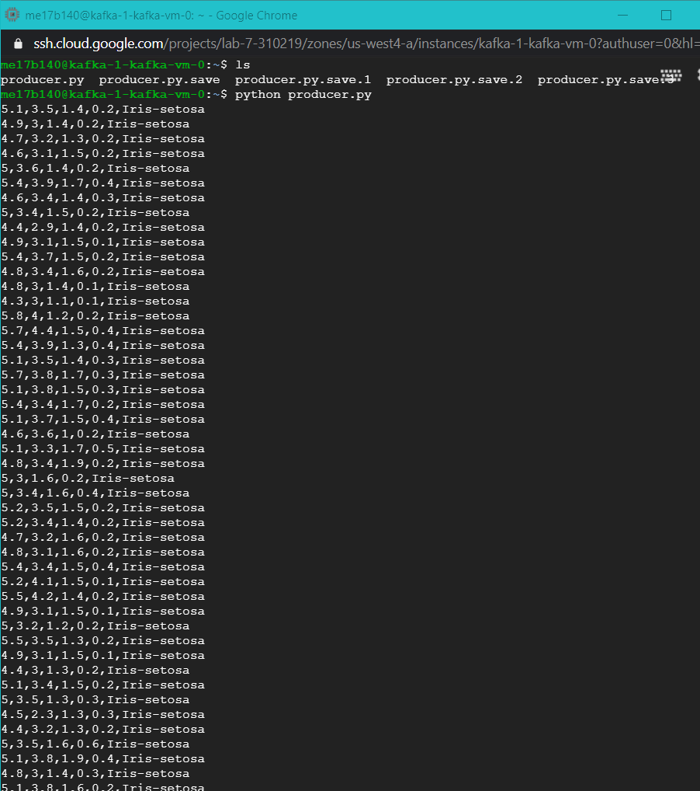

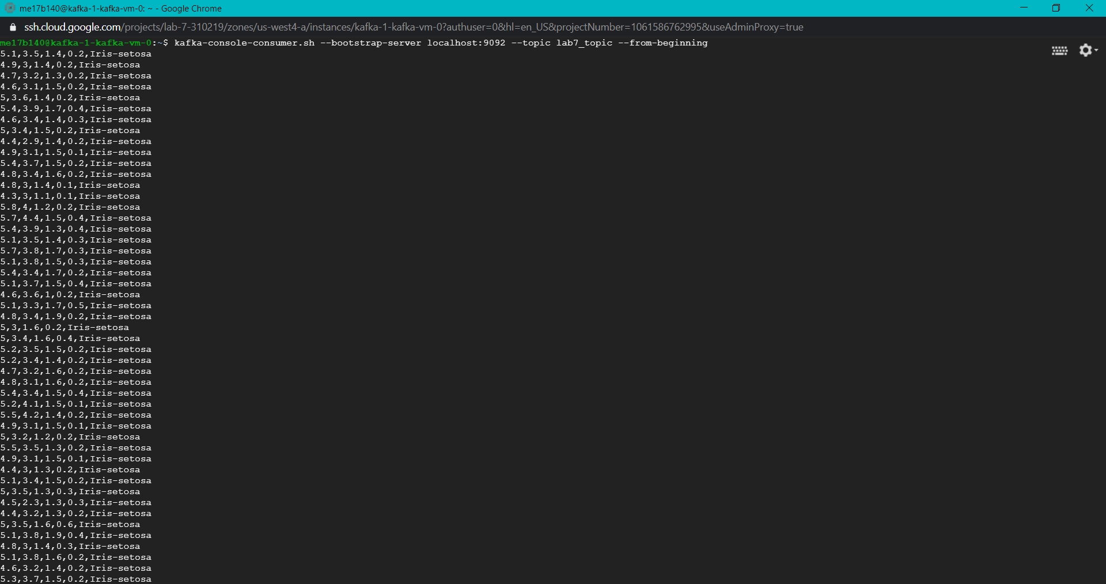

1. 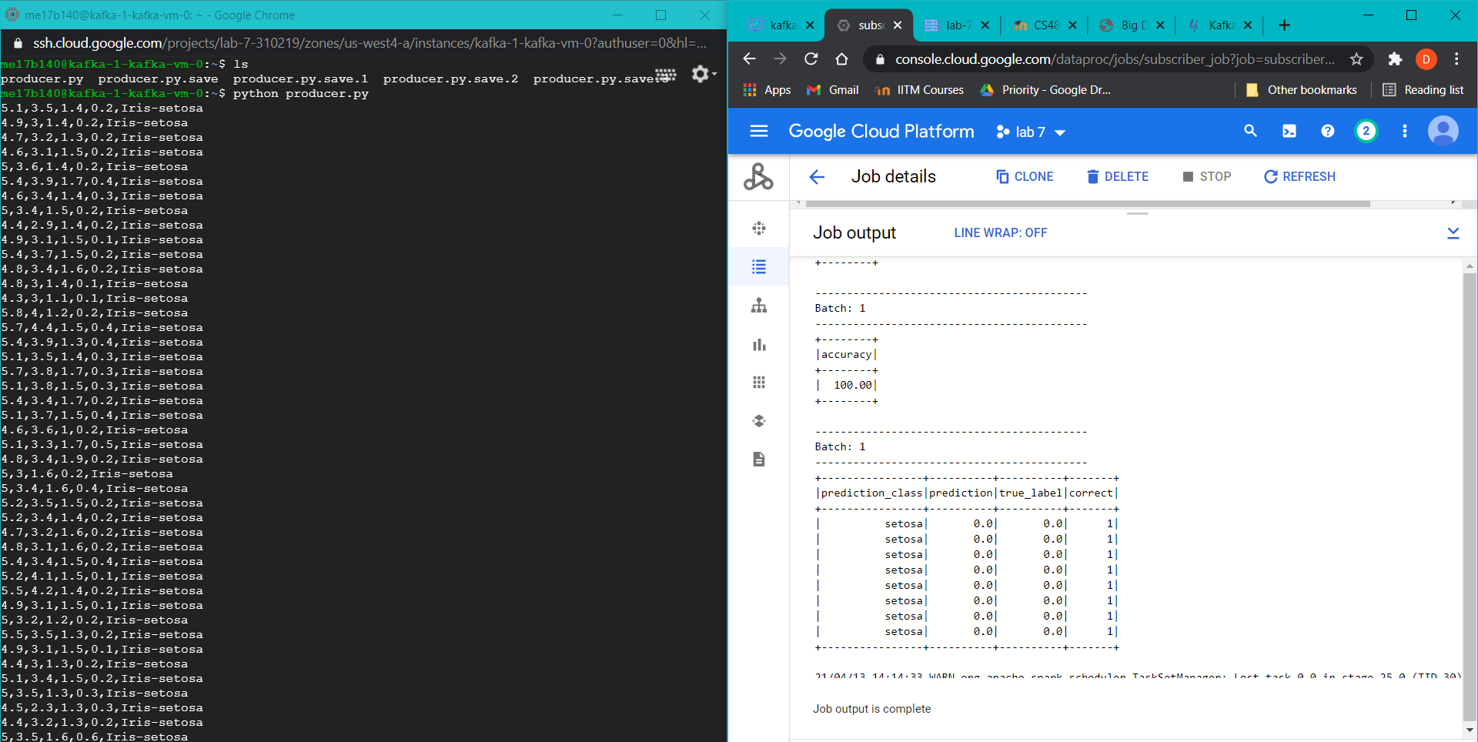 ***Console output while publishing the data:***

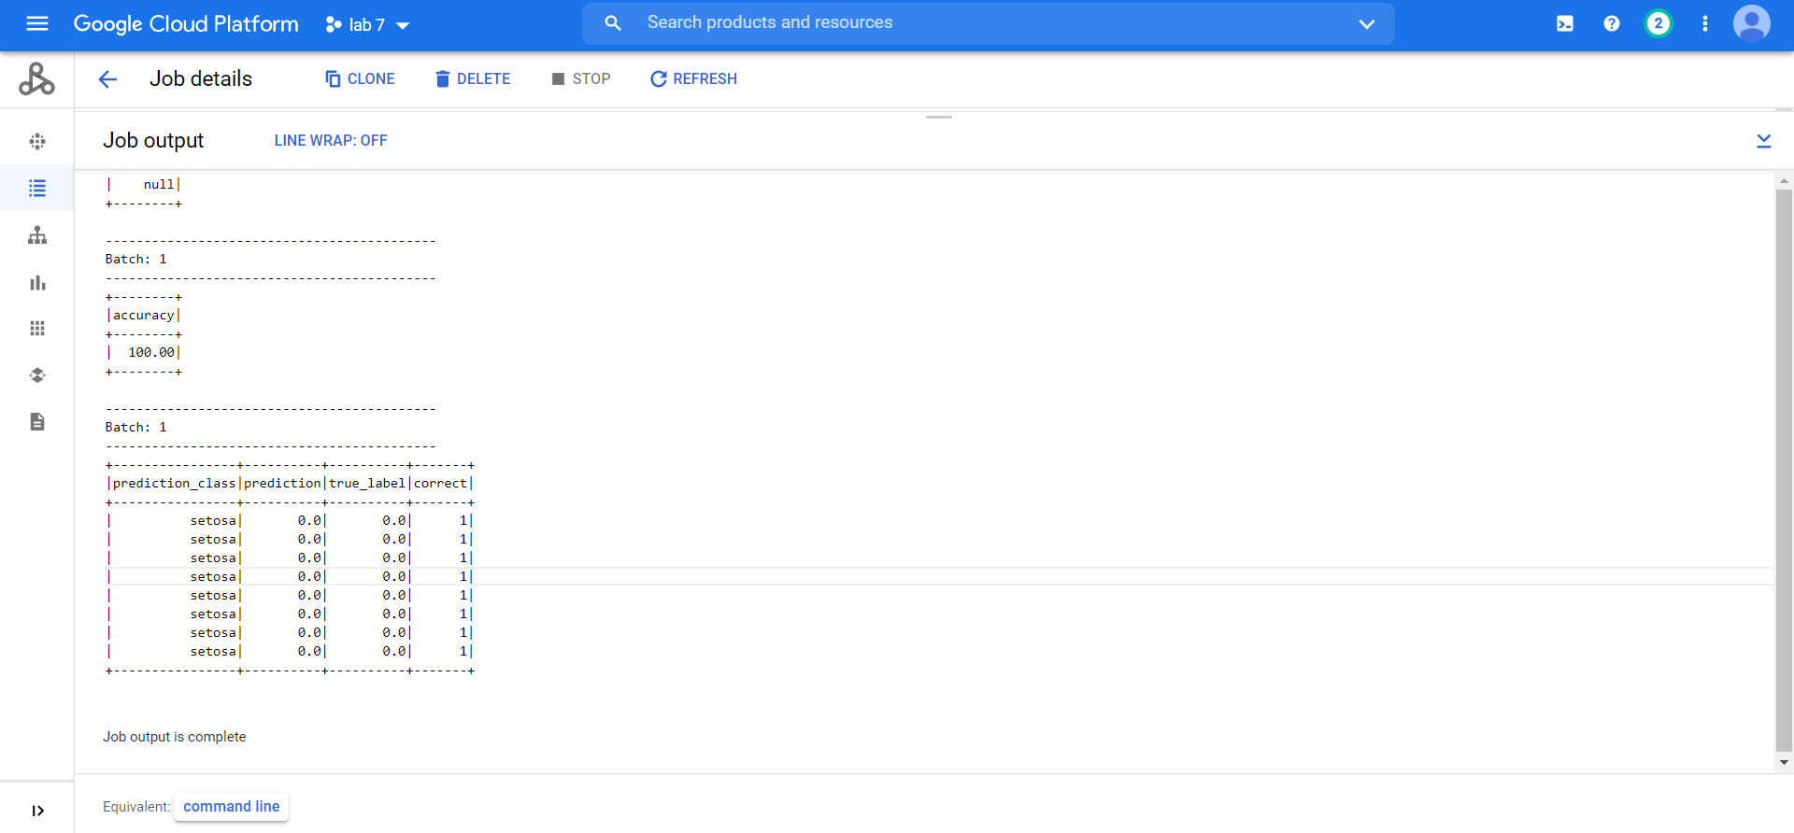***Console output:***

From lab 5 the Random Forest classifier model is saved and is used for this labs task. The saved model is in the below screenshot, placed in the bucket.

